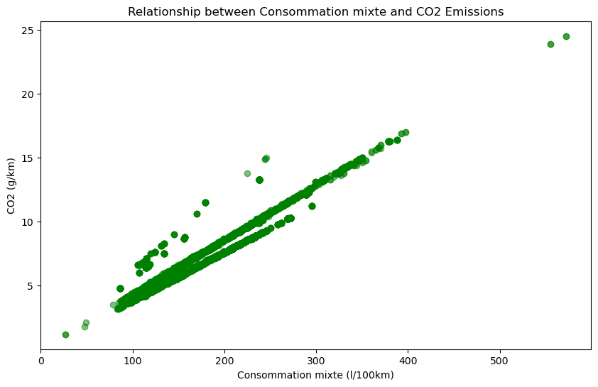

Abbildung 1: Relationship between Consomation Mixte and Co2 Emissions

The scatterplot illustrates a clear positive correlation between fuel consumption ('Consommation mixte') and CO2 emissions. The main trendline slopes from the bottom left to the top right, indicating that vehicles with higher fuel consumption tend to have higher CO2 emissions.

There are two additional lines observed at approximately 70 l/100 km. One line runs below the main trendline up to around 300 l/100 km, while the other runs at the same height but above the main trendline. These additional lines suggest potential subgroups or distinct characteristics within the data:

* Below the main line up to around 300 l/100 km: Vehicles in this range may possess specific attributes leading to lower CO2 emissions despite higher fuel consumption.
* Above the main line up to around 300 l/100 km: Vehicles in this range may have characteristics resulting in higher CO2 emissions, even with relatively lower fuel consumption.

Further exploration and subgroup analysis could provide insights into the unique features influencing CO2 emissions within these fuel consumption ranges.

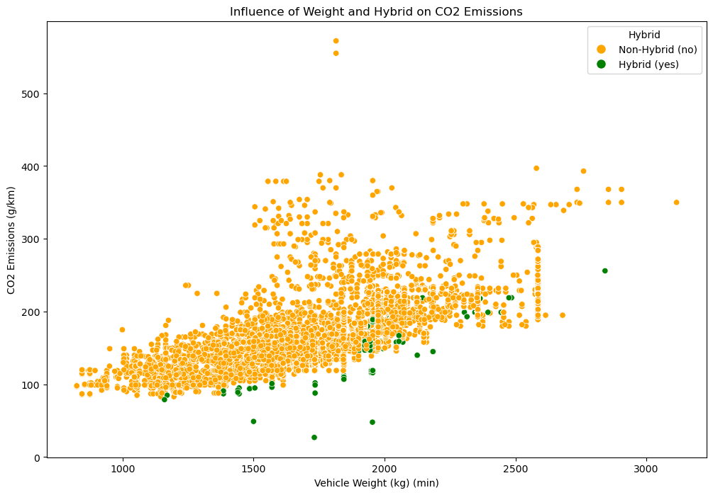

Abbildung 2:Influence of weight and Hybrid on Co2 Emmissions

Weight and Hybrid Influence on CO2 Emissions:

* For vehicles with a weight below approximately 1800 kg (minimum weight), the green points (Hybrid vehicles) seem to have generally lower CO2 emissions compared to the orange points (Non-Hybrid vehicles). This could suggest that Hybrid vehicles may be more efficient in terms of CO2 emissions at lighter weights.
* From a weight of about 1800 kg onwards, there appears to be a mixing of green and orange points, indicating that the influence of vehicle weight on CO2 emissions becomes more similar between Hybrid and Non-Hybrid vehicles.

It would be interesting to conduct additional analyses, such as dividing the data into weight ranges and examining average CO2 emissions in these ranges. This could help further explore the relationship between weight, hybrid properties, and CO2 emissions.

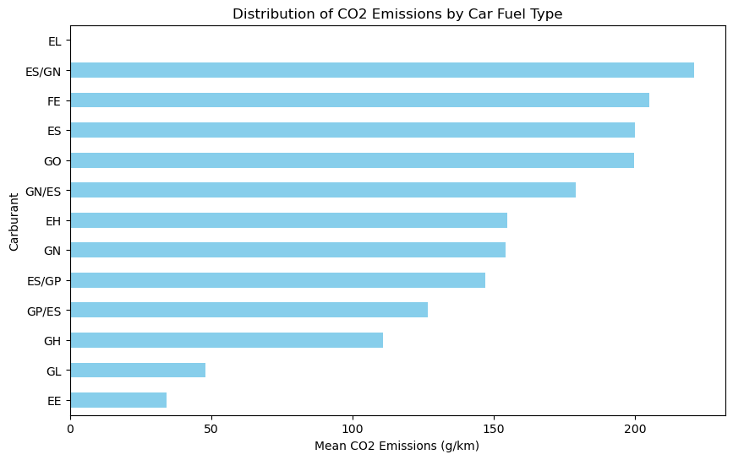

Figure 3. Distribution of CO2 emissions by car fuel type

The horizontal bar plot we created shows the mean CO2 emissions for different car fuel types.

The order of the bars from top to bottom represents the ascending order of mean CO2 emissions. Here's an interpretation based on our observation:

* ES/GN (Ethanol/Gasoline): This category has the highest mean CO2 emissions among the displayed fuel types. It indicates that vehicles using a combination of Ethanol and Gasoline tend to emit more CO2 on average.
* EE (Electric/Electric): This category represents vehicles that are fully electric (Electric) and use an electric powertrain exclusively.

The "EE" category has the lowest mean CO2 emissions among the displayed fuel types. The low CO2 emissions in this category indicate a reduced carbon footprint compared to vehicles with other fuel types.

* EL (Electric/LPG): The absence of a bar for this category in the plot suggests that there might be very few or no vehicles with the combination of Electric and LPG in the dataset. As a result, the dataset does not provide sufficient information to calculate a meaningful mean CO2 emissions value for this particular fuel type.

This is information about other fuel types:

FE (Electric)

ES (Electric/Gasoline) and Go (Gasoline)

GN/ES (Natural Gas/Electric)

EH (Electric/Hybrid)

GN (Natural Gas)

ES/GP (Electric/LPG)

GP/ES (LPG/Electric)

GH (Gasoline/Hybrid)

GL (LPG/Hybrid)

We need to consider that these interpretations are based on the mean values, and individual vehicles within each category may vary in their CO2 emissions.

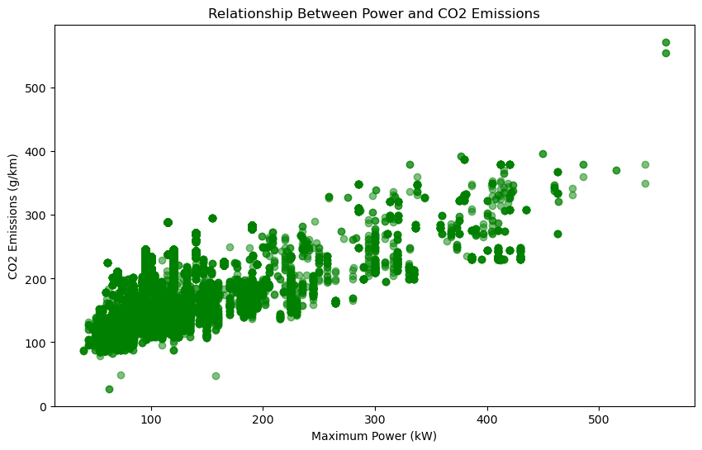

Figure 4. Relationship between power and CO2 emissions

we can identify two observations based on this diagram:

* Vehicles with more power tend to have higher CO2 emissions and vice versa. This observation aligns with general expectations, as vehicles with higher power often have larger engines and may consume more fuel.
* A large number of data points are concentrated within a specific range of power values, such as between approximately 50 and 250. But, we have a large number of data points concentrated within a specific range of power values, such as between approximately 50 and 250. The concentration of data points in a specific power range may indicate that many vehicles in the dataset share similar power characteristics. But, we need to explore the dataset further to see popular models or manufacturers within this power range. Vehicles with extremely high power values (e.g., greater than 400 kW) are often high-performance or specialty vehicles. These could include sports cars, luxury vehicles, or other niche segments. The limited number of data points in this range might be reflective of the relatively lower production volume of such vehicles compared to mainstream models.